SASKEXPRESS SASKATOON
REQUIRED ATTIRE/SHOE LIST 2024-2025

BALLET

LEVEL 1, 2, 3 & 4 BALLET/BALLET TECHNIQUE 1 & 2/RECREATIONAL/TEEN BALLET: Leather Full Sole

Female Identifying: Pink

Capezio Lily Child Ballet Slipper

Capezio Lily Ballet Slipper- 212W

Bloch Girls Dansoft Full Sole Leather Ballet Slipper- SO205G

Bloch Ladies Full Sole Leather Ballet Slipper- SO205L

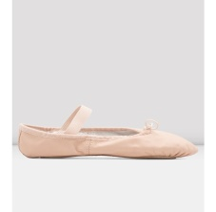

Male Identifying: Black

Bloch Boys Dansoft Full Sole Leather Ballet Slipper- SO205G

Bloch Mens Full Sole Leather Slipper- SO205L

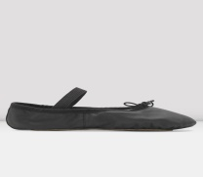

Non-Binary:

Full Sole Leather Ballet Slipper in your choice of colour

LEVEL 5 & 6 BALLET/BALLET TECHNIQUE 3/ADULT BALLET: Canvas Split Sole

Female Identifying: Pink

Bloch Performa Canvas Ballet Shoe- SO284L

Sansha Pro1 Canvas

Capezio Hanami Ballet Slippers- 2037W

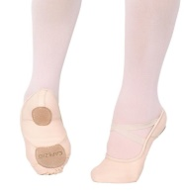

Male Identifying: Black

So Danca Ballet Slippers-SD16

Capezio Mr Ballet Slipper

Sansha Pro1 Canvas

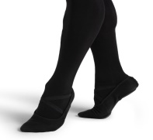

Non-Binary:

Split Sole Canvas Ballet Slipper in your choice of colour

DEMI-POINTE:

Female Identifying: Pink

Bloch Performa Canvas Ballet Shoe- SO284L

Sansha Pro1 Canvas

Capezio Hanami Ballet Slippers- 2037W

Convertible Tights to access bare feet

Male Identifying: Black

So Danca Ballet Slippers-SD16

Capezio Mr Ballet Slipper

Sansha Pro1 Canvas

Removable socks or convertible tights to access bare feet

Non-Binary:

Split Sole Canvas Ballet Slipper in your choice of colour

POINTE SHOES: A well fitted pointe shoe, suitable to each individual – it is recommended that students have their teachers present to fit their first pair at Dance Street. Students will not purchase pointe shoes until the class teacher tells them they are ready to do so.

POINTE: With ribbons (and elastics if needed)

A well fitted pointe shoe, suitable to each individual. If dancers need to purchase a new pair in a new style, it is advised to coordinate having their teacher present to assist in the new fitting at Dance Street.

JAZZ

ALL LEVELS OF JAZZ/SYLLABUS CLASS/RECREATIONAL JAZZ/ADULT JAZZ: No laces. NOTE: Some levels may be asked to purchase both beige and black.

Female Identifying: Beige

Bloch Child Elasta Bootie Jazz Shoe-SO499G

Bloch Child Neo Flex Jazz Shoe= SO495G

Bloch Adult Elasta Bootie Jazz Shoes- SO499L

Bloch Adult Neo Flex Jazz Shoe- SO495L

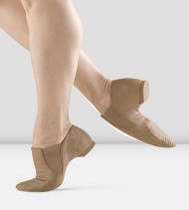

Male Identifying: Black

Bloch Child Elasta Bootie Jazz Shoe-SO499G

Bloch Child Neo Flex Jazz Shoe= SO495G

Bloch Adult Elasta Bootie Jazz Shoes- SO499L

Bloch Adult Neo Flex Jazz Shoe- SO495L

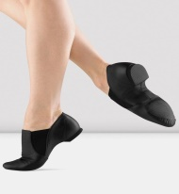

Non-Binary:

Leather Jazz Oxford with split sole in your choice of colour

ENRICHMENTS: Jazz Oxfords, Block Spin, Foot Undies and Bare feet – dancers do not need to purchase all styles. Bring what you have to class.

Female Identifying: Beige

Bloch Child Elasta Bootie Jazz Shoe-SO499G

Bloch Child Neo Flex Jazz Shoe= SO495G

Bloch Adult Elasta Bootie Jazz Shoes- SO499L

Bloch Adult Neo Flex Jazz Shoe- SO495L

Male Identifying: Black

Bloch Child Elasta Bootie Jazz Shoe-SO499G

Bloch Child Neo Flex Jazz Shoe= SO495G

Bloch Adult Elasta Bootie Jazz Shoes- SO499L

Bloch Adult Neo Flex Jazz Shoe- SO495L

Non-Binary:

Jazz Oxford with split sole in your choice of colour

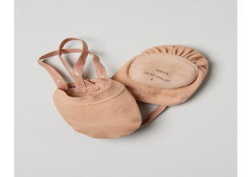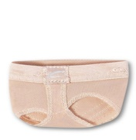

NOVICE FOUNDATIONS:

Female Identifying:

Bloch Adult Elasta Bootie Jazz Shoes- SO499L

Bloch Adult Neo Flex Jazz Shoe- SO495L

Male Identifying:

Bloch Adult Elasta Bootie Jazz Shoes- SO499L

Bloch Adult Neo Flex Jazz Shoe- SO495L

Non-Binary:

Jazz Oxford with split sole in your choice of colour

HE DANCES TOO:

Bloch Child Elasta Bootie Jazz Shoe-SO499G

Bloch Child Neo Flex Jazz Shoe= SO495G

Bloch Adult Elasta Bootie Jazz Shoes- SO499L

Bloch Adult Neo Flex Jazz Shoe- SO495L

TAP

LEVELS 1 & 2 TAP/SYLLABUS CLASS: No Slip on Oxfords or Split Sole Tap

Female Identifying: BEIGE

Capezio Child Mary Jane- 3800C

Bloch Child Tap-On Tap Shoe- SO302G

Capezio Adult Mary Jane- 3800

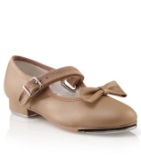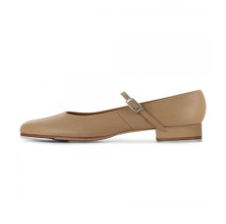

Male Identifying: BLACK

Capezio Tic Tap Toe Tap Shoe

Capezio Child Fluid Tap- CG17C

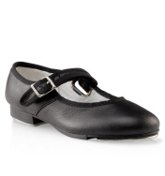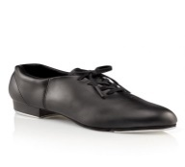

Non-Binary:

Full Sole Tap shoe with buckle of oxford with laces in your choice of colour

LEVEL 3 TAP/SYLLABUS CLASS/RECREATIONAL TAP: NO Slip on Oxfords or Split Sole Tap

Female Identifying: BEIGE

Capezio Cadence Tap Shoes Adult- CG19

Capezio Premiere Tap-CG09

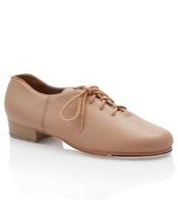

Male Identifying: BLACK

Capezio Cadence Tap Shoes Adult- CG19

Capezio Premiere Tap-CG09

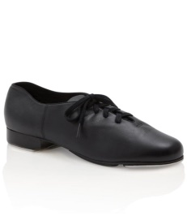

Non-Binary:

Full Sole Tap Oxford with Laces in your choice of colour

ADULT TAP:

Female & Male Identifying &Non-Binary:

Any style black tap shoe

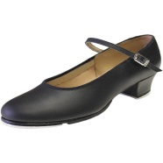

ACRO

ACRO: RECREATIONAL/COMPETITIVE:

Female Identifying:

Convertible or Capri Tights

Bare feet

Capezio Foot Undee- H07 – needed for performances

Male Identifying:

Bare feet

Capezio Foot Undee- H07 – needed for performances

Non-Binary:

Convertible or Capri Tights

Bare feet

Capezio Foot Undee- H07 – needed for performances

PRESCHOOL ACRODANCE:

Bare Feet

HIP HOP

HIP HOP – ALL LEVELS: All Black, Clean Indoor High Top Runners (never worn outside)

Male & Female Identifying & Non-Binary:

Black High Top Runners – no white accents – all black

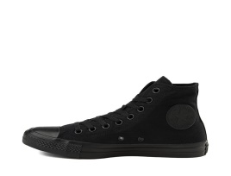

CONTEMPORARY

CONTEMPORARY – All LEVELS:

Female & Male identifying & Non-Binary:

Bloch Spin II- SO639

Capezio Hanami Pirouette- H064W

LYRICAL

LYRICAL – ALL LEVELS:

Female Identifying: Beige

Bloch Child Elasta Bootie Jazz Shoe-SO499G

Bloch Child Neo Flex Jazz Shoe= SO495G

Bloch Adult Elasta Bootie Jazz Shoes- SO499L

Bloch Adult Neo Flex Jazz Shoe- SO495L

Male Identifying: Black

Bloch Child Elasta Bootie Jazz Shoe-SO499G

Bloch Child Neo Flex Jazz Shoe= SO495G

Bloch Adult Elasta Bootie Jazz Shoes- SO499L

Bloch Adult Neo Flex Jazz Shoe- SO495L

Non-Binary:

Jazz Oxford with split sole in your choice of colour

SPARK PRESCHOOL/CREATIVE TOTS & KIDS

SPARK PRESCHOOL:

Male & Female identifying & Non-Binary: beige or black in tap and jazz shoes are acceptable

Tap: Capezio Child Mary Jane- 3800C OR Capezio Tot Mary Jane- 3800T (must have Velcro closure)

Jazz: Bloch Child Elasta Bootie Jazz Shoe-SO499G or Bloch Child Neo Flex Jazz Shoe= SO495G (no laces)

CREATIVE TOTS & KIDS – FOUNDATIONS: Ballet & Jazz

Female Identifying: Ballet/Jazz

Capezio Lily Child Ballet Slipper

Bloch Girls Dansoft Full Sole Leather Ballet Slipper- SO205G

Male Identifying: Ballet/Jazz

Bloch Boys Dansoft Full Sole Leather Ballet Slipper- SO205G

Non-Binary:

Full Sole Leather Ballet Slipper in your choice of colour

CREATIVE TOTS & KIDS - RHYTHMS: Jazz & Tap

Female Identifying: Black or Beige Jazz

Bloch Child Elasta Bootie Jazz Shoe-SO499G

Bloch Child Neo Flex Jazz Shoe= SO495G

Female Identifying: Black or Beige Tap

Capezio Child Mary Jane- 3800C

Bloch Child Tap-On Tap Shoe- SO302G

Capezio Adult Mary Jane- 3800

Male Identifying: Black Jazz

Bloch Child Elasta Bootie Jazz Shoe-SO499G

Bloch Child Neo Flex Jazz Shoe= SO495G

Male Identifying: Black Tap

Capezio Tic Tap Toe Tap Shoe

Capezio Child Fluid Tap- CG17C

Non-Binary:

Jazz Oxford with split sole in your choice of colour

Full sole Tap shoe with buckle or tap oxford with laces in your choice of colour

COME DANCE WITH ME:

Female Identifying:

Capezio Lily Child Ballet Slipper

Capezio Lily Ballet Slipper- 212W

Bloch Girls Dansoft Full Sole Leather Ballet Slipper- SO205G

Bloch Ladies Full Sole Leather Ballet Slipper- SO205L

Male Identifying:

Bloch Boys Dansoft Full Sole Leather Ballet Slipper- SO205G

Bloch Mens Full Sole Leather Slipper- SO205L

Non-Binary:

Full Sole Leather Ballet Slipper

Adult Companion: Socks or Bare feet

DRAMA & VOCAL

IMP-ACT:

Female & Male Identifying & Non-Binary:

Clean Indoor Shoes (never worn outside)

IMPROV CLUB:

Female & Male Identifying & Non-Binary:

Clean Indoor Shoes (never worn outside)

TICKLE TRUNK CREATIONS:

Both Female and Male Identifying/Non-Binary:

Clean indoor shoes (never worn outside)

STORYTIME JAM:

Both Female and Male Identifying/Non-Binary:

Clean indoor shoes (never worn outside)

ACT-IVATE:

Both Female and Male Identifying/Non-Binary:

Clean indoor shoes (never worn outside)

COLLABORATIVE CREATIONS:

Both Female and Male Identifying/Non-Binary:

Clean indoor shoes (never worn outside)

VOCAL VARIATIONS:

Female & Male Identifying & Non-Binary:

Clean Indoor Shoes (never worn outside)

Bloch Child Elasta Bootie Jazz Shoe-SO499G

Bloch Child Neo Flex Jazz Shoe= SO495G

MUSICAL THEATRE

ALL MUSICAL THEATRE PROGRAMMING INCLUDING MINI AND EXPRESSIONS: No Laces

Female Identifying: Beige

Bloch Child Elasta Bootie Jazz Shoe-SO499G

Bloch Child Neo Flex Jazz Shoe= SO495G

Bloch Adult Elasta Bootie Jazz Shoes- SO499L

Bloch Adult Neo Flex Jazz Shoe- SO495L

Male Identifying: Black

Bloch Child Elasta Bootie Jazz Shoe-SO499G

Bloch Child Neo Flex Jazz Shoe= SO495G

Bloch Adult Elasta Bootie Jazz Shoes- SO4

Non-Binary:

Jazz Oxford with split sole in your choice of colour

BROADWAY BOUND:

Female Identifying:

Bloch Adult Elasta Bootie Jazz Shoes- SO499L

Bloch Adult Neo Flex Jazz Shoe- SO495L

Male Identifying:

Bloch Adult Elasta Bootie Jazz Shoes- SO499L

Bloch Adult Neo Flex Jazz Shoe- SO495L

Non-Binary:

Jazz Oxford with split sole in your choice of colour

BROADWAY NOW:

Female Identifying:

Bloch Adult Elasta Bootie Jazz Shoes- SO499L

Bloch Adult Neo Flex Jazz Shoe- SO495L

Male Identifying:

Bloch Adult Elasta Bootie Jazz Shoes- SO499L

Bloch Adult Neo Flex Jazz Shoe- SO495L

Non-Binary:

Jazz Oxford with split sole in your choice of colour

JUNGLE RHYTHMS:

Female Identifying:

Bloch Adult Elasta Bootie Jazz Shoes- SO499L

Bloch Adult Neo Flex Jazz Shoe- SO495L

Male Identifying:

Bloch Adult Elasta Bootie Jazz Shoes- SO499L

Bloch Adult Neo Flex Jazz Shoe- SO495L

Non-Binary:

Jazz Oxford with split sole in your choice of colour

WILLY WONKA JR:

Female Identifying:

Bloch Adult Elasta Bootie Jazz Shoes- SO499L

Bloch Adult Neo Flex Jazz Shoe- SO495L

Male Identifying:

Bloch Adult Elasta Bootie Jazz Shoes- SO499L

Bloch Adult Neo Flex Jazz Shoe- SO495L

Non-Binary:

Jazz Oxford with split sole in your choice of colour

ANASTASIA YOUTH EDITION:

Female Identifying:

Bloch Adult Elasta Bootie Jazz Shoes- SO499L

Bloch Adult Neo Flex Jazz Shoe- SO495L

Male Identifying:

Bloch Adult Elasta Bootie Jazz Shoes- SO499L

Bloch Adult Neo Flex Jazz Shoe- SO495L

Bloch Adult Neo Flex Jazz Shoe- SO495L

Non-Binary:

Jazz Oxford with split sole

MICKEY’S MAGICAL DANCE PARTY:

Female Identifying:

Bloch Adult Elasta Bootie Jazz Shoes- SO499L

Bloch Adult Neo Flex Jazz Shoe- SO495L

Male Identifying:

Bloch Adult Elasta Bootie Jazz Shoes- SO499L

Bloch Adult Neo Flex Jazz Shoe- SO495L

Non-Binary:

Jazz Oxford with split sole in your choice of colour

ADULT CABARET:

Female Identifying:

Bloch Adult Elasta Bootie Jazz Shoes- SO499L

Bloch Adult Neo Flex Jazz Shoe- SO495L

Male Identifying:

Bloch Adult Elasta Bootie Jazz Shoes- SO499L

Bloch Adult Neo Flex Jazz Shoe- SO495L

Non-Binary:

Jazz Oxford with split sole in your choice of colour

